[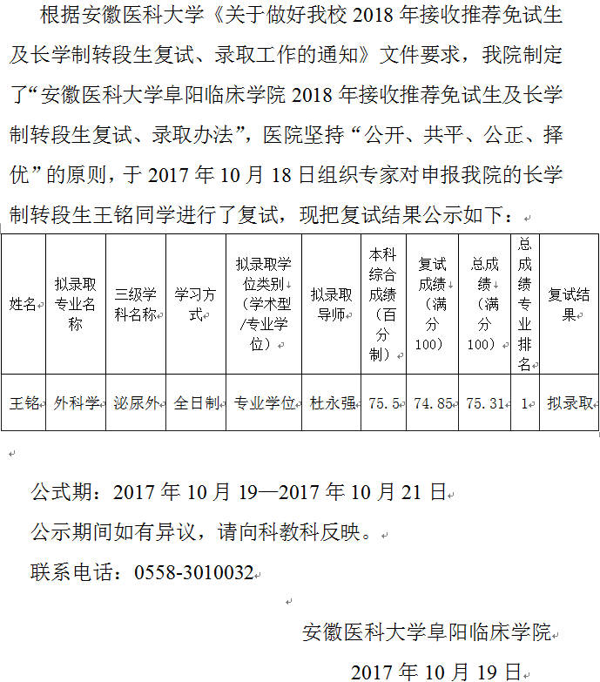](http://www.fysyy.com/files/105711/1710/y_1a15251581.jpg)