**[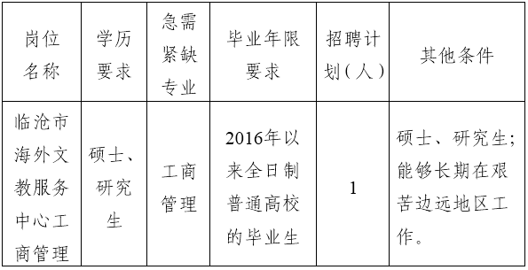](http://www.lincang.gov.cn/Gggs/UploadFiles_8173/201806/2018060118485220.png)**